Cetacean strandings in the US Pacific Northwest – spatio-temporal trends reveal potential linkages to climate and oceanographic variability

Running head: Cetacean strandings and oceanographic conditions

Amanda J. Warlick1 | Jessica L. Huggins2 | Dyanna M. Lambourn3 | Deborah A. Duffield4 | Dalin D’Alessandro4 | James M. Rice5 | John Calambokidis2 | Brad Hanson6 | Joseph K. Gaydos7 | Steven J. Jeffries3 | Jennifer Olson8 | Jonathan Scordino9 | Adrianne Akmajian9 | Matthew Klope10 | Susan Berta10 | Sandy Dubpernell10 | Betsy Carlson11 | Susan Riemer12 | Jan Hodder13 | Victoria Souze14 | Alysha Elsby14 | Cathy King15 | Kristin Wilkinson16 | Tiffany Boothe17 | Stephanie A. Norman18

1ECS Federal ECS Federal, LLC, Seattle, Washington

2Cascadia Research Collective, Olympia, Washington

3Washington Department of Fish and Wildlife, Marine Mammal Investigations, Lakewood, Washington

4Biology Department, Portland State University, Portland, Oregon

5Marine Mammal Institute, Oregon State University, Newport, Oregon

6NOAA Northwest Fisheries Science Center, Seattle, Washington

7Karen C. Drayer Wildlife Health Center-Orcas Island Office, School of Veterinary Medicine, University of California Davis, Eastsound, Washington

8The Whale Museum, Friday Harbor, Washington

9Makah Tribe, Neah Bay, Washington

10Orca Network, Central Puget Sound Marine Mammal Stranding Network, Freeland, Washington

11Betsy Carlson, Port Townsend Marine Science Center, Port Townsend, Washington

12Oregon Department of Fish and Wildlife, Salem, Oregon

13Oregon Institute of Marine Biology, University of Oregon, Charleston, Oregon

14Whatcom County Marine Mammal Stranding Network, Lummi Island, Washington

15World Vets, Gig Harbor, Washington

16NOAA Fisheries, Protected Resources Division, West Coast Region, Seattle, Washington

17Seaside Aquarium, Seaside, Oregon

18Marine-Med: Marine Research, Epidemiology, and Veterinary Medicine, Bothell, Washington

Correspondence:

KEYWORDS: cetaceans, climate change, El Niño Southern Oscillation, harbor porpoise, large-scale climate changes, multivariate ENSO index, strandings, trends

Paper type: Primary Research Article

**1** | **Introduction**

Over the past several decades, marine mammal stranding records have been used as an indicator of ocean and cetacean health (Bogomolni et al., 2010; Bossart, 2011; Gulland & Hall, 2007). Examining where, when, and how often marine mammals strand can provide insight into ecological behaviors, reproductive success, (Norman et al., 2004; Pikesley et al., 2011), the impacts of human activities (Warlick et al., 2018), and species distributions (Evans et al., 2005; MacLeod et al., 2005). Cetaceans are strongly influenced by changes in the marine environment via diverse and dynamic mechanisms, including changes in sea surface temperature, winds, or large-scale oceanographic oscillations that can shift the balance of nutrients and prey species abundance and distribution. These small changes are often amplified up through the food web or exacerbated by increased pollutants or algal blooms, ultimately having noticeable effects on top predators. Examining changes in strandings over time provides important information for monitoring cetacean populations, tracking distribution or abundance trends, and examining emerging health or disease conditions, particularly in light of recent documented changes in oceanographic conditions on both local and regional scales (Pierce, Santos, Smeenk, Saveliev, & Zuur, 2007; Sprogis, Christiansen, Wandres, & Bejder, 2017; Truchon et al. 2013).

As top predators of their respective food webs, marine mammals may be especially sensitive to these changes (Evans, Pierce, & Panigada, 2010; Moore 2008). Recent studies have found correlations between long-term stranding trends and several indices of climatic variability, demonstrating how strandings may be used as bio-indicators of prevailing environmental conditions. Evans et al. (2005) found that cetacean strandings in southeast Australia exhibited a periodicity coincident with regional wind patterns. Factors such as sea ice and the North Atlantic Oscillation have been found to correlate with strandings and mortality of certain pinniped and cetacean species in Gulf of St. Lawrence, Canada (Johnston, Bowers, Friedlaender, & Lavigne, 2012; Soulen, Cammen, Schultz, & Johnston, 2013; Truchon et al. 2013). Keledjian and Mesnick (2013) found that El Niño conditions corresponded with increased California sea lion (*Zalophus californianus*) strandings and fisheries interactions along the California coast. Berini, Kracker, & McFee (2015) found that pygmy whale strandings in the southeast U.S. were correlated with sea surface temperatures, wind, and other oceanographic indicators. Gray whale (*Eschrichtius robustus*) mother-calf pair counts in their summer feeding grounds have been linked to sea ice conditions during the previous feeding season, while distribution of mother-calf pairs in some calving areas in Mexico are influenced by ENSO-related variability (Salvadeo, Nájera-Caballero, Urbán-Ramirez, & Lluch-Belda, 2015). Increases in harbor porpoise (*Phocoena phocoena*) strandings over the last 12 years in the Pacific Northwest have been posited to be partially due to changes in their prey’s abundance and distribution (Greene, Kuehne, Rise, Fresh, & Penttila, 2015; Jefferson, Smultea, Courbis, & Campbell, 2016). Because responses to environmental change are complex, variable, species-dependent, and often poorly understood, oceanographic features should be studied over varying scales (local and continental), ecotypes, and species (Evans & Bjørge, 2013; Laidre, Stirling, Lowry, Wiig, Heide-Jørgensen, & Ferguson, 2008; Truchon et al. 2013).

Environmental changes are acknowledged to be occurring on a global scale (IPCC, 2014), though the local realization of these changes is patchy and difficult to predict due to varying degrees of ecosystem complexity and spatial heterogeneity (Evans and Bjørge, 2013; Jacox et al., 2016; Moore, 2008). The Pacific Northwest, or as it is sometimes referred to as Cascadia, is a loosely defined region region that includes coastal, inland, and estuarine waters extending from northern California through British Columbia, including the Salish Sea and the mouth of the Columbia River (Coates, 2002). It is an ecosystem that contains important feeding and breeding habitat for numerous marine mammal species in the eastern north Pacific and beyond, including gray (*Eschrichtius robustus*) and humpback (*Megaptera novaeangliae*) whales, endangered southern resident killer whales (*Orcinus orca*), and numerous smaller delphinid and phocoenid species. In recent years, the California Current ecosystem experienced an “extreme marine heat wave” that became known as The Blob, where above average water temperatures persisted from 2014-2016, causing a wide range of changes, including shifts in primary production, fish spawning, larval abundance, and marine wildlife health (Auth, Daly, Brodeur, & Fisher, 2017; Bond, Cronin, Freeland, & Mantua, 2015; DiLorenzo & Mantua, 2016). These conditions along the U.S. West Coast along with increasing ocean acidification and harmful algal blooms in the Pacific Northwest (Mauger et al., 2015; Mote & Salathé, 2010) can negatively impact marine mammal population dynamics through changes in the abundance and distribution of their prey, among other effects.

We aimed to investigate the possible connection between oceanographic variability and the health and mortality of marine mammals throughout a large ecosystem by evaluating stranding records collected consistently and systematically from 2003-2017. Specifically, the goals of this study were to: compare recent cetacean stranding numbers and patterns in the Pacific Northwest to those previously reported for 1930-2002 (Norman et al., 2004); use strandings as a proxy to detect changing prevalence of cetacean species within certain geographic areas; and to investigate possible relationships between spatiotemporal variation in cetacean strandings and oceanographic conditions in the Pacific Northwest. This information is useful for both researchers and stranding responders studying the baseline and future health and status of these cetacean populations in a multi-use ecosystem subject to human impacts and exhibiting signs of degradation and environmental change.

It was expected that strandings of humpback whales and harbor porpoises, for example, might be higher than previously reported for the region (Norman et al., 2004) due to recent anomalous ocean conditions and/or changes in prey availability. We hypothesized that oceanographic variables such as sea surface temperature anomalies, upwelling, large-scale oceanographic processes (e.g., El Niño/Southern Oscillation [ENSO]/Pacific Decadal Oscillation [PDO]), harmful algal blooms as well as changes in prey availability, would be associated with alterations in strandings of specific species depending on how they use the Pacific Northwest marine ecosystem (year-round residents versus migratory and breeding versus feeding habitat) (*e.g.,* Truchon et al. 2013).

**2** | **MATERIALS AND METHODS**

**2.1** | **Stranding data and characterization**

We compiled all available records of cetacean strandings (2003-2017) that are maintained by the National Oceanic and Atmospheric Administration’s (NOAA’s) National Marine Fisheries Service (NMFS) and its stranding response network members in Oregon and Washington. Completed stranding reports are typically submitted to NMFS’ national stranding database by network members each year and include data such as field identification number, observation date, stranding location, and when determinable, age class, sex, status (dead or alive), species, evidence of injury or human interaction, and postmortem condition. Some reports, including photos, are received from the public through various media outlets (phone calls, texts, or emails). Reports containing ambiguous species identification, regardless of source, were included in one of several ‘Unknown’ categories based on the level of information known. Entangled live cetaceans or strandings attributed directly to human activity such as ship strikes were excluded.

Records were aggregated by year, season, sex, and stranding location. Seasons were defined as Spring: March-May; Summer: June-August; Fall: September-November; Winter: December-February. Similar to Warlick et al. (20018), three stranding location regions were analyzed because stranding response, logistics, and species’ presence differ among these areas – Oregon, outer Washington coast, and inland Washington waters (inland of the mouth of the Strait of Juan de Fuca).

**2.2** | **Environmental data**

The environmental and prey density data used in this analysis (Table 1) were obtained from the California Current Integrated Ecosystem Assessment (IEA) project data portal[1] unless otherwise noted.

**2.2.1** | **Local oceanographic conditions and prey densities**

Sea surface temperature (SST, °C) values were used from northern California (buoy 46014, 39°N/124°W) and central Oregon (buoy 46050, 45°N/125°W). SST anomalies were calculated by subtracting a given month SST value from a long-term (since 1981) mean SST in that month (*e.g.*, mean of all Januaries 1981-2017 minus January 2005). Monthly upwelling values (from 39ºN/125ºW and 45ºN/125ºW) were included because seasonal upwelling in the California Current greatly drives primary production and fish prey density along the West Coast. Meridional winds at 39ºN and 45ºN were initially investigated but ultimately omitted due to strong correlation with upwelling values.

Copepod biomass anomaly (CBA) measures for cold-water copepod species (“northern”) and warm-water species (“southern”) can represent the seasonal composition of the zooplankton community. The typical pattern of northern CBA prominence during the summer and southern CBA prominence in the winter can be disrupted when the PDO is in a warm phase or during El Niño events (Peterson & Keister 2003). Including these measures as covariates was hypothesized to potentially represent cetaceans’ response to ecosystem-level food web changes. Prey density values for anchovy, sardine, and market squid are based on catch per unit effort estimates from summer trawls off the coast of Oregon and Washington (44-48ºN). These measures are tentatively included in this analysis, though they may not accurately represent forage species availability along the coast, particularly for species with diurnal movements in the water column.

**2.2.2** | **Large-scale oceanographic oscillations**

Variables used to assess the effect of large-scale, climatic factors on strandings included: (1) the Multivariate ENSO index (MEI) index, (2) the Pacific Decadal Oscillation (PDO) index, and (3) the North Pacific Gyre Oscillation (NPGO) index, all of which were obtained from the California Current IEA at the monthly level. The MEI describes ENSO conditions since it combines six meteorological measures over portions of the Pacific Ocean (Wolter & Timlin, 1993). Large positive MEI values indicate the occurrence of El Niño conditions, while large negative MEI values indicate La Niña conditions. The presence of El Niño conditions was also included as a categorical variable. The PDO represents a recurring pattern of climate variability (Mantua & Hare, 2002) with historical records strongly suggesting an association with salmon production (Beamish et al., 1999; Hare, Mantua, & Francis, 1999) and zooplankton production in the eastern North Pacific (Francis, Hare, Hollowed, & Wooster, 2003). The NPGO is largely driven by sea surface height variability and is thought to influence salinity and nutrient concentrations (DiLorenzo et al. 2008).

Oceanographic indices were examined in real-time and with one, two, and three-month lags while prey density variables were only considered in real-time. Because many of the oceanographic variables are inter-related, we tested for collinearity between variables using a Pearson’s correlation coefficient. All of the local and basin-wide oceanographic and prey indices at different buoy locations and lag times amounted to a total of 55 potential covariates. Though this is a large number, we chose to consider them all due to the wide range of cetacean species with different life histories and behaviors that could be influenced by environmental conditions at varying spatial and temporal scales.

**2.3** | **Statistical analysis**

To determine whether the number of cetacean strandings was significantly different across categorical variables such as sex, species, season, or regional location, we conducted pairwise Kruskal-Wallis Nemenyi tests in R (R Development Core Team, 2009) with sex and species as independent variables and the number of stranding cases as the dependent variable. The six species with the highest number of strandings over the study period were analyzed separately. To qualitatively examine spatio-temporal stranding patterns across seasons and regions, hotspot maps were generated with a kernel density estimation (Gatrell, Bailey, Diggle, & Rowlingson, 1996) with three bins (`geom_density2d` function in the ggplot2 R package).

To examine whether strandings increased over the study period and to assess whether variability in monthly strandings correlated with oceanographic conditions, we used poisson regressions with a log link to account for overdispersion and negative binomial generalized linear model regressions for species with fewer cases to account for a higher number of zeros. Due to having a large number of potential covariates, we used an automated model selection function (`regsubsets` in the leaps R packages, respectively) to narrow down the list of covariates and then selected the final most parsimonious model by minimizing the Akaike’s Information Criterion (AIC) (Akaike, 1973) in conjunction with biological relevance and removing highly correlated covariates. Model fitting and selection for species whose best models included estimates of prey densities were repeated excluding those covariates for reasons noted above. Deviance goodness-of-fit tests were conducted to examine overall model significance, though this may be somewhat less reliable with small counts. Regression coefficients were exponentiated for relevance on the response scale, with values >1.0 representing a positive multiplicative correlation and values <1.0 representing a negative relationship.

**3** | **RESULTS**

**3.1 | Summary of stranding events**

Over the study period (2003-2017), 1,463 strandings were recorded in Oregon (*n* = 516) and Washington (*n* = 946) (Table 2) across 26 species and a hybrid combination (*Phocoena* *phocoena*/*Phocoenoides dalli*), comprising 195 mysticetes, 1,245 odontocetes, and 23 cetacean spp. Nearly all cases (96%) were identified to species level. Mean annual strandings for harbor porpoises (*n* = 958) and gray whales (*n* = 131) amounted to 64 and 9 cases per year, respectively, and represented nearly 75% of total strandings (Table 2). Mean annual strandings for humpback whales, 3 per year, represented 2.6% of total stranding numbers. Striped dolphins (*Stenella coeruleoalba*) were the most commonly stranded species in the Family Delphinidae (annual mean = 4.7; 3% of all strandings), with 80% of reports originating in Oregon. Approximately one-third of strandings were not identified for sex and there was no significant difference between the number of males and females over the study period for any of the six most commonly stranded species: harbor porpoise, gray whale, Dall’s porpoise (*Phocoenoides dalli*), striped dolphin, humpback whale, and Pacific white-sided dolphin (*Lagenorhynchus obliquidens*). Of the total stranding cases, 18.5% (*n* = 271) were documented as human interaction cases, the majority of which were harbor porpoises (Table 2). For the most part, the number of HI cases is proportional to the number of total strandings for each species with the exception of fin whales, where two-thirds of the stranding cases were anthropogenic in nature.

**3.2 | Temporal distribution**

Over the study period, combined strandings increased significantly over time (stats), though this pattern varied across species (Figure 1). Harbor porpoise strandings increased throughout the 2000s and then peaked in 2012. Striped dolphin strandings in the study area have increased substantially since 2003 while Dall’s porpoise strandings have decreased (Figure 1). Gray whale strandings have fluctuated interannually with little apparent directional trend while humpback whale strandings were high in 2010 and 2016 (Figure 1). The total number of human interaction cases has also increased over time from approximately 10 cases per year to more than 30 per year. For the six most commonly stranding species, the increasing or variable temporal pattern of HI cases is similar to that of overall strandings, particularly evident for harbor porpoise and gray whales (Figure 2).

Overall, there was a significant difference in the number of strandings per season, with fewer strandings in the fall and winter (average of 13-15 per year per season) compared with the spring and summer (average 30-39 per year per season) (χ2 = 159.2, p < 0.001). This pattern was driven largely by harbor porpoises, but was also evident for gray whales (Figure X). However, humpback whales showed a different seasonal pattern, with higher average strandings in the summer and fall compared to the winter and spring (Figure X). In contrast, fewest strandings of striped dolphins were recorded in the summer and the most were recorded in the fall and winter.

**3.2 | Geographic distribution**

Overall, the number of strandings reported in inland Washington waters was significantly higher than that reported along the coasts (χ2 = 67.7, p < 0.001), though this is largely driven by spatial patterns in harbor porpoise strandings while other species exhibit different patterns (Figure 1S). Other frequently stranding species exhibited different spatial trends, with a higher number of striped dolphins stranding in Oregon, Dall’s porpoises in inland Washington waters, and gray whales along the Oregon coast and inland Washington waters (Figure 3). At the seasonal level, gray and humpback whale strandings were concentrated further south during fall compared with other months when more strandings occurred in Washington (Figure 3). For harbor porpoises, cases were concentrated further north in fall and winter.

**3.4 | Oceanographic conditions**

Models were fit for species with a sufficient number of stranding cases per year, namely, harbor porpoise, gray whale, striped dolphin, and Dall’s porpoise. Of the 55 potential covariates evaluated as predictors of monthly stranding cases, 8 were included as significant in best predictive models. As noted above, all coefficients were exponentiated for meaningful interpretation on the response scale (values >1.0 indicate positive multiplicative relationship and values <1.0 indicate negative) (Table 3). For harbor porpoise, the best model of annual stranding cases included two-month lagged SST at 44° (y = 0.73, p < 0.001), one-month lagged MEI (y = 0.87, p = 0.09), northern CBA (not significant), market squid (y = 2.58, p < 0.01), and sardine CPUE (y = 0.59, p < 0.01) (AIC = 660.25, χ2 = 0.49). This model would predict higher strandings with higher market squid CPUE and lower strandings when warmer SST and MEI conditions had been present over the preceding months. Without proxies for prey density, the best model included two-month lagged SST at 44° (y = 0.75, p <0.01) and MEI and northern CBA (not significant) (AIC = 674.56, χ2 = 0.48) for a model that would predict fewer strandings when warmer SST was present in the preceding months.

For grey whales, the best model included upwelling at 39° (y = 0.99, p=0.03), one-month lagged MEI (y = 0.77, p = 0.03), and northern CBA (y = 0.67, p=0.03) (AIC = 192.24, χ2 = 0.96), describing a model that would predict fewer strandings with predominant northern copepod species and warm phase MEI, and upwelling having a negligible effect. For Dall’s porpoise, the best model included SST anomalies at 39° (not significant), one-month lagged NPGO (y = 0.76, p=0.05), and sardine CPUE (y = 1.52, p=0.08) (AIC = 124.35, χ2 = 0.99), meaning that higher NPGO values would lead to fewer strandings while higher sardine CPUE might coincide with higher strandings. Without prey density, the best model for Dall’s porpoise did not include any significant covariates. ~~For combined dolphinidae species, the best model included two-month lagged SST at 39° and one-month lagged PDO (AIC = 192.56, χ~~~~2~~ ~~= 0.99).~~ The best model for striped dolphin strandings included one-month lagged MEI (y = 2.47, p = 0.04) and northern CBA (not significant) (AIC = 62.09, χ2 = 0.98), where this model would predict higher strandings with warm phase MEI values in the preceding month.

**4** | **DISCUSSION**

Time to make an outline….

Here’s how I see one logical flow that mirrors the sections we have above in methods/results:

**General trends**: strandings generally and often represent/indicate locally/temporally abundant species.

* Did that pan out for us?
  + I think we need some brief descriptive sentences about the life history/range of The Six species we chose to highlight, or some others that are relevant that might have surprising results or those that differ from Norman et al.
* Anything to note about sex? –not really due to large proportion of unk.
* How do these values relate to Norman et al? (though it is hard to compare since I did not use linear regressions, maybe compare mean annual cases?)
* Some species have increased and others have decreased?
* Anything to say about general HI cases? Sorta small sample size

**Temporal trends**:

* Do seasonal stranding patterns reflect what we understand about seasonal presence/absence of species in the area? Why or why not?

**Geographic trends**:

* Could combine and answer this in one category of spatio-temporal trends, since they are so closely related, but same question as above, do geographic trends reflect what we generally think we know about the spatial extent of these species? Why or why not? Range expansions or other HI-related issues?

**Ocean**:

* Without fixating on the models too much (I personally am still on the fence about model selection, AIC, my own skills, etc., so I’m not sure how much to say here, but at least:
  + Species are all different and would theoretically respond to different environmental conditions at different spatial and temporal scales.
  + Find something to say about the models for each species, and particularly interesting that most of the covariates don’t seem to have a very large effect size, though most are negative?
* Could spend at least a paragraph or two outlining future steps/possibilities
  + Better prey availability metrics
  + Longer timeseries consideration would be better for oceanographic indices
  + Stronger methodological pairing between where/when conditions are experienced compared with where/when strandings are reported (drift, lag, etc.)
  + Better description of why we think this matters for a few of the species – why would california current prey density matter, etc?
  + How might be comment on or tie back to future climate variability/change?

**Conclusion:**

* Strandings are increasing and are influenced by oceanographic drivers
* Monitoring and long time-series perspective is important (relatedness to Norman et al)
* Implications for cetacean health, stranding response, management/conservation, and climate change?

Misc. Notes/ideas:

“Years with abundant pelagic fish, market squid and krill are generally associated with cooler waters, strong upwelling and higher productivity (Santora et al. 2014, McClatchie et al. 2016).”

<https://www.pcouncil.org/wp-content/uploads/2018/02/F1a_NMFS_Rpt1_2018_IEA_SoCC_FINAL_main_Mar2018BB.pdf>

ACKNOWLEDGEMENTS

This research was made possible through the hard work and dedication of all stranding response network work members in the Pacific Northwest, including Cascadia Research Collective, Central Puget Sound Marine Mammal Stranding Network, Dungeness National Wildlife Refuge & Protection Island, Feiro Marine Life Center, Makah Tribe, Marine Animal Rescue Center, MaST Center Stranding Team, Olympic Coast National Marine Sanctuary, Oregon State University Marine Mammal Institute, Port Townsend Marine Science Center, Portland State University, San Juan County Marine Mammal Stranding Network, Seal Sitters, Seaside Aquarium, Sno-King Marine Mammal Response, The Whale Museum, Vashon Hydrophone Project, Washington Dept of Fish and Wildlife Marine Mammal Investigations, and Whatcom Marine Mammal Stranding Network. In addition to the numerous volunteer hours invested in collecting the data presented, many stranding networks were the recipients of numerous U.S. Federal grants through the John H. Prescott Marine Mammal Rescue Assistance Grant Program, which supplied essential funding for this work.

ORCID

*Amanda J. Warlick* https://orcid.org/0000-0003-0926-1672

*Stephanie A. Norman* https://orcid.org/0000-0001-5491-3866

REFERENCES

Akaike, H. (1973). Information theory and an extension of maximum likelihood principle. In

B. N. Petrov & F. Csaki (Eds.), *Second International Symposium on Information Theory* (pp. 267-281). Budapest, Hungary: Akademiai Kiado.

Auth, T. D., Daly, E. A., Brodeur, R. D., & Fisher, J. L. (2017). Phenological and distributional shifts in ichthyoplankton associated with recent warming in the northeast Pacific Ocean. *Global Change Biology,* *24,* 259-272. https://doi.org/10.1111/gcb.13872

Bakun, A. (1973). Coastal upwelling indices, west coast of North America, 1946–71. U.S.

Department of Commerce, NOAA Technical Report NMFS–SSRF–671.

Beamish, R. J., Noakes, D. J., McFarlane, G. A., Klyashtorin, L., Ivanov, V. V., & Kurashov, V.

(1999). The regime concept and natural trends in the production of Pacific salmon.

*Canadian Journal of Fisheries and Aquatic Sciences, 56,* 516-526. http://www.nrcresearchpress.com/doi/10.1139/f98-200#.W3353-hKjD4

Berini, C. R., Kracker, L. M., & McFee, W. E. (2015). Modeling pygmy sperm whale (*Kogia breviceps*, De Blainville 1838) strandings along the southeast coast of the United States from 1992 to 2006 in relation to environmental factors. NOAA Technical Memorandum NOS NCCOS 203 (pp. 44). Charleston, SC: NOAA Technical Memorandum. Retrieved from https://doi.org/10.7289/V5/TM-NOS-NCCOS-203 (accessed 13 August 2018).

Bogomolni, A. L., Pugliares, K. R., Sharp, S. M., Patchett, K., Harry, C.T., LaRocque, J. M.,

Touhey, K. M., & Moore, M. (2010). Mortality trends of stranded marine mammals on Cape Cod and southeastern Massachusetts, USA, 2000 to 2006. *Diseases of Aquatic Organisms, 88*, 143-155. https://doi.org/10.3354/dao02146

Bond, N. A., Cronin, M. F., Freeland, H., & Mantua, N. J. (2015). Causes and impacts of the

2014 warm anomaly in the NE Paciﬁc. *Geophysical Research Letters, 42,* 3414-3420. doi:10.1002/2015GL063306. https://doi.org/10.1002/2015GL063306

Bond, N. A., M. F. Cronin, H. Freeland, and N. J. Mantua (2015), Causes and impacts of the 2014 warm anomaly in the NE Paciﬁc, Geophys.

Res. Lett., 42, 3414–3420, doi:10.1002/2015GL063306.

Bossart, G. D. (2011). Marine mammals as sentinel species for oceans and human health.

*Veterinary Pathology, 48,* 676-690. https://doi.org/10.1177%2F0300985810388525

Coates, K. S. (2002). 1. Border Crossings. In J. M. Findlay, & K. S. Coates (Eds.), *Parallel*

*destinies: Canadian-American relations west of the Rockies* (pp. 3-30). Seattle and London: University of Washington Press.

Cotté, C., & Simard, Y. (2005). Formation of dense krill patches under tidal forcing at whale

feeding hot spots in the St. Lawrence Estuary. *Marine Ecology Progress Series, 288,* 199-210. <https://doi:10.3354/meps288199>

Di Lorenzo E., Schneider N., Cobb K. M., Chhak, K, Franks P. J. S., Miller A. J., McWilliams J. C., Bograd S. J., Arango H., Curchister E., Powell T. M. and P. Rivere, 2008: North Pacific Gyre Oscillation links ocean climate and ecosystem change. *Geophys. Res. Letters*, *35*, L08607, doi:10.1029/2007GL032838.

DiLorenzo, E., & Mantua, N. (2016). Multi-year persistence of the 2014/15 North Paciﬁc marine heatwave. *Nature Climate Change, 6,* 1042-1047, doi:10.1038/NCLIMATE3082.

Evans, K., Thresher, R., Warneke, R. M., Bradshaw, C. J. A., Pook, M., Thiele, D., & Hindell,

M. A. (2005). Periodic variability in cetacean strandings: links to large-scale climate events. *Biology Letters, 1,* 147-150. https://dx.doi.org/10.1098%2Frsbl.2005.0313

Evans, P. G. H., Pierce, G. J., & Panigada, S. (2010). Climate change and marine mammals.

*Journal of the Marine Biological Association of the United Kingdom, 90,* 1483-1487. https://doi.org/10.1017/S0025315410001815

Evans, P. G. H., & Bjørge, A. (2013). Impacts of climate change on marine mammals. *Marine*

*Climate Change Impacts Partnership: Science Review 2013,* 134-148.

https://doi:10.14465/2013.arc15.134-148

Fire, S. E., Wang, Z., Berman, M., Langlois, G. W., Morton, S. L., Sekula-Wood, E., & Benitez-

Nelson, C. R. (2010). Trophic transfer of the harmful algal toxin domoic acid as a cause of death in a minke whale (*Balaenoptera acutorostrata*) stranding in southern California. *Aquatic Mammals, 36,* 342-350. https://doi:10.1578/AM.36.4.2010.342

Flewelling, L. J., Naar, J. P., Abbott, J. P., Baden, D. G., Barros, N. B., Bossart, G. D., . . .

Landsberg, J. H. (2005). Red tides and marine mammal mortalities. *Nature, 435,* 755-756. https://www.nature.com/articles/nature435755a

Francis, R. C., Hare, S. R., Hollowed, A. B., & Wooster, W. S. (2003). Effects of interdecadal

climate variability on the oceanic ecosystems of the NE Pacific. *Fisheries Oceanography, 7,* 1-21. https://doi.org/10.1046/j.1365-2419.1998.00052.x

Gatrell, A. C., Bailey, T. C., Diggle, P. J., & Rowlingson, B. S. (1996). Spatial point pattern

analysis and its application in geographical epidemiology. *Transactions of the Institute of*

*British Geographers, 21,* 256-274. https://www.jstor.org/stable/622936

Greene, C., Kuehne, L., Rise, C., Fresh, K., & Penttila, D. (2015). Forty years of change in

forage fish and jellyfish abundance across greater Puget Sound, Washington (USA):

anthropogenic and climate associations. *Marine Ecology Progress Series, 525,* 153-170. https://doi.org/10.3354/meps11251

Gulland, F. M. D., & Hall, A. J. (2007). Is marine mammal health deteriorating? Trends in the

global reporting of marine mammal disease. *EcoHealth, 4,* 135-150. https://doi.org/10.1007/s10393-007-0097-1

Hare, S. R., Mantua, N. J., & Francis, R. C. (1999). Inverse production regimes: Alaskan and

West Coast Salmon. *Fisheries, 24,* 6-14. https://doi.org/10.1577/1548-8446(1999)024%3C0006:IPR%3E2.0.CO;2

Hemery, G., D’Amico, F., Castege, I., Dupont, B., D’Elbee, J., LaLanne, Y., & Mouches, C.

(2008). Detecting the impact of oceano-climatic changes on marine ecosystems using a multivariate index: The case of the Bay of Biscay (North Atlantic-European Ocean). *Global Change Biology, 14,* 27-38. https://doi.org/10.1111/j.1365-2486.2007.01471.x

IPCC (2014). Climate change 2014: Synthesis report. Contribution of working groups I, II and

III to the fifth assessment report of the Intergovernmental Panel on Climate Change. In Core Writing Team, RKPaLaME (Ed.), Report of the Intergovernmental Panel on Climate Change. Geneva: IPCC.

Jacox, M. G., Hazen, E. L., Zaba, K. D., Rudnick, D. L., Edwards, C. A., Moore, A. M., &

Bograd, S. J. (2016). Impacts of the 2015–2016 El Niño on the California Current System: early assessment and comparison to past events. *Geophysical Research Letters, 43,* 7072-7080. https://doi.org/10.1002/2016GL069716

Jefferson, T. A., Smultea, M. A., Courbis, S. S., & Campbell, G. S. (2016). Harbor porpoise

(*Phocoena* *phocoena*) recovery in the inland waters of Washington: estimates of density

and abundance from aerial surveys, 2013–2015. *Canadian Journal of Zoology, 94,* 505-515. https://doi.org/10.1139/cjz-2015-0236

Johnston, D. W., Bowers, M. T., Friedlaender, A. S., & Lavigne, D. M. (2012). The effects of

climate change on harp seals (*Pagophilus groenlandicus*). *PLoS One, 7,* e29158. https://doi.org/10.1371/journal.pone.0029158

Keledjian, A., & Mesnick, S. L. (2013). The impacts of El Niño conditions on California sea lion

(*Zalophus californianus*) fisheries interactions: predicting spatial and temporal hotspots along the California coast. *Aquatic Mammals, 39,* 221-232. https://doi:10.1578/AM.39.3.2013.221

Laidre, K. L., Stirling, I., Lowry, L., Wiig, Ø., Heide-Jørgensen, M. P., & Ferguson, S. H.

(2008). Quantifying the sensitivity of arctic marine mammals to climate-induced habitat change. In H. P. Huntington & S. E. Moore (Eds.), Arctic marine mammals and climate change. *Ecological Applications, 18 (Supplement),* S97-S125. https://doi.org/10.1890/06-0546.1

MacLeod, C. D., Bannon, S. M., Pierce, G. J., Schweder, C., Learmonth, J. A., Herman, J. S., &

Reid, R. J. (2005). Climate change and the cetacean community of north-west Scotland. *Biological Conservation, 124,* 477-483. https://doi.org/10.1016/j.biocon.2005.02.004

Mantua, N. J., & Hare, S. R. (2002). The Pacific Decadal Oscillation. *Journal of Oceanography,*

*58,* 35-44. https://doi.org/10.1023/A:1015820616384

Mauger, G. S., Casola, J. H., Morgan, H. A., Strauch, R. L., Jones, B., Curry, B., . . . Snover, A.

K. (2015). State of Knowledge: Climate Change in Puget Sound. Report prepared for the Puget Sound Partnership and the National Oceanic and Atmospheric Administration. Climate Impacts Group, University of Washington, Seattle. doi:10.7915/CIG93777D. Retrieved from https://cig.uw.edu/resources/special-reports/ps-sok/ (accessed 2 August 2018).

Moore, S. E. (2008). Marine mammals as ecosystem sentinels. *Journal of Mammalogy, 89,* 534–

540. https://doi.org/10.1644/07-MAMM-S-312R1.1

Mote, P. W., & Salathé Jr., E. P. (2010). Future climate in the Pacific Northwest. *Climate*

*Change, 102,* 29-50. https://doi.org/10.1007/s10584-010-9848-z

Murase, H., Matsuoka, K., Ichii, T., & Nishiwaki, S. (2002). Relationship between the

distribution of euphausiids and baleen whales in the Antarctic (35 degrees E-145 degrees W). *Polar Biology, 25,* 135-145. https://doi.org/10.1007/s003000100321

Norman, S. A., Bowlby, C. E., Brancato, M. S., Calambokidis, J., Duffield, D., Gearin, P. J., . . .

Scordino, J. (2004). Cetacean strandings in Oregon and Washington between 1930 and 2002. *Journal of Cetacean Research and Management, 6,* 87-100.

Peterson, W. T., and J. E. Keister. (2003). Interannual variability in copepod community composition at a coastal station in the northern California Current: a multivariate approach. *Deep Sea Research Part II: Topical Studies in Oceanography 50*(14–16): 2499–2517.

Pierce, G. J., Santos, M. B., Smeenk, C., Saveliev, A., & Zuur, A. F. (2007). Historical trends in

the incidence of strandings of sperm whales (*Physeter macrocephalus*) on North Sea

coasts: An association with positive temperature anomalies. *Fisheries Research, 87,* 219-228. https://doi.org/10.1016/j.fishres.2007.06.001

Pikesley, S. K., Witt, M. J., Hardy, T., Loveridge, J., Loveridge, J., Williams, R., & Godley, B. J.

(2012). Cetacean sightings and strandings: evidence for spatial and temporal trends? *Journal of the Marine Biological Association of the United Kingdom, 92,* 1809-1820. https://doi.org/10.1017/S0025315411000464

R Development Core Team. 2009. R: A language and environment for statistical computing.

Vienna, Austria: R Foundation for Statistical Computing.

Salvadeo, C. J., Gómez-Gallardo, U. A., Nájera-Caballero, M., Urbán-Ramirez, J., & Lluch-

Belda D. (2015). The effect of climate variability on gray whales (*Eschrichtius robustus*) within their wintering areas. *PLoS One, 10,* e0134655. doi:10.1371/journal.pone.0134655.

Soulen, B. K., Cammen, K., Schultz, T. F., & Johnston, D. W. (2013). Factors affecting harp seal (*Pagophilus groenlandicus*) strandings in the northwest Atlantic. *PLoS One, 8,* e68779. https://doi.org/10.1371/journal.pone.0068779.

Sprogis, K. R., Christiansen, F., Wandres, M., & Bejder, L. (2017). El Niño Southern Oscillation

influences the abundance and movements of a marine top predator in coastal waters. *Global Change Biology, 24,* 1085-1096. https://doi.org/10.1111/gcb.13892

Truchon, M.-H., Measures, L., L’Hérault, V., Brêthes, J.-C., Galbraith, P. S., Harvey, M., . . .

Lecomte, M. (2013). Marine mammal strandings and environmental changes: a 15-year study in the St. Lawrence ecosystem. *PLoS One, 8,* e59311. https://doi.org/10.1371/journal.pone.0059311

Warlick, A. J., Duffield, D. A., Lambourn, D. M., Jeffries, S. J., Rice, J. M., Gaydos, J. K., …

Norman, S. A. (2018). Spatio-temporal characterization of pinniped strandings and

human interaction cases in the Pacific Northwest, 1991-2016. *Aquatic Mammals, 44,* 299-318. https://doi.org/10.1578/AM.44.3.2018.299

Wolter, K., & Timlin, M. S. (1993). Monitoring ENSO in COADS with a seasonally adjusted

principal component index. In Proceedings of the 17th Climate Diagnostics Workshop, NOAA/N MC/CAC, NSSL, Oklahoma Climate Survey, CIMMS and the School of Meteorology, University of Oklahoma, Norman, OK. Retrieved from https://www.esrl.noaa.gov/psd/enso/mei/WT1.pdf (accessed 18 August 2018).

Wolter, K., & Timlin, M. S. (1998). Measuring the strength of ENSO events—how does 1997/98

rank? *Weather, 53,* 315-324. https://doi.org/10.1002/j.1477-8696.1998.tb06408.x

SUPPORTING INFORMATION

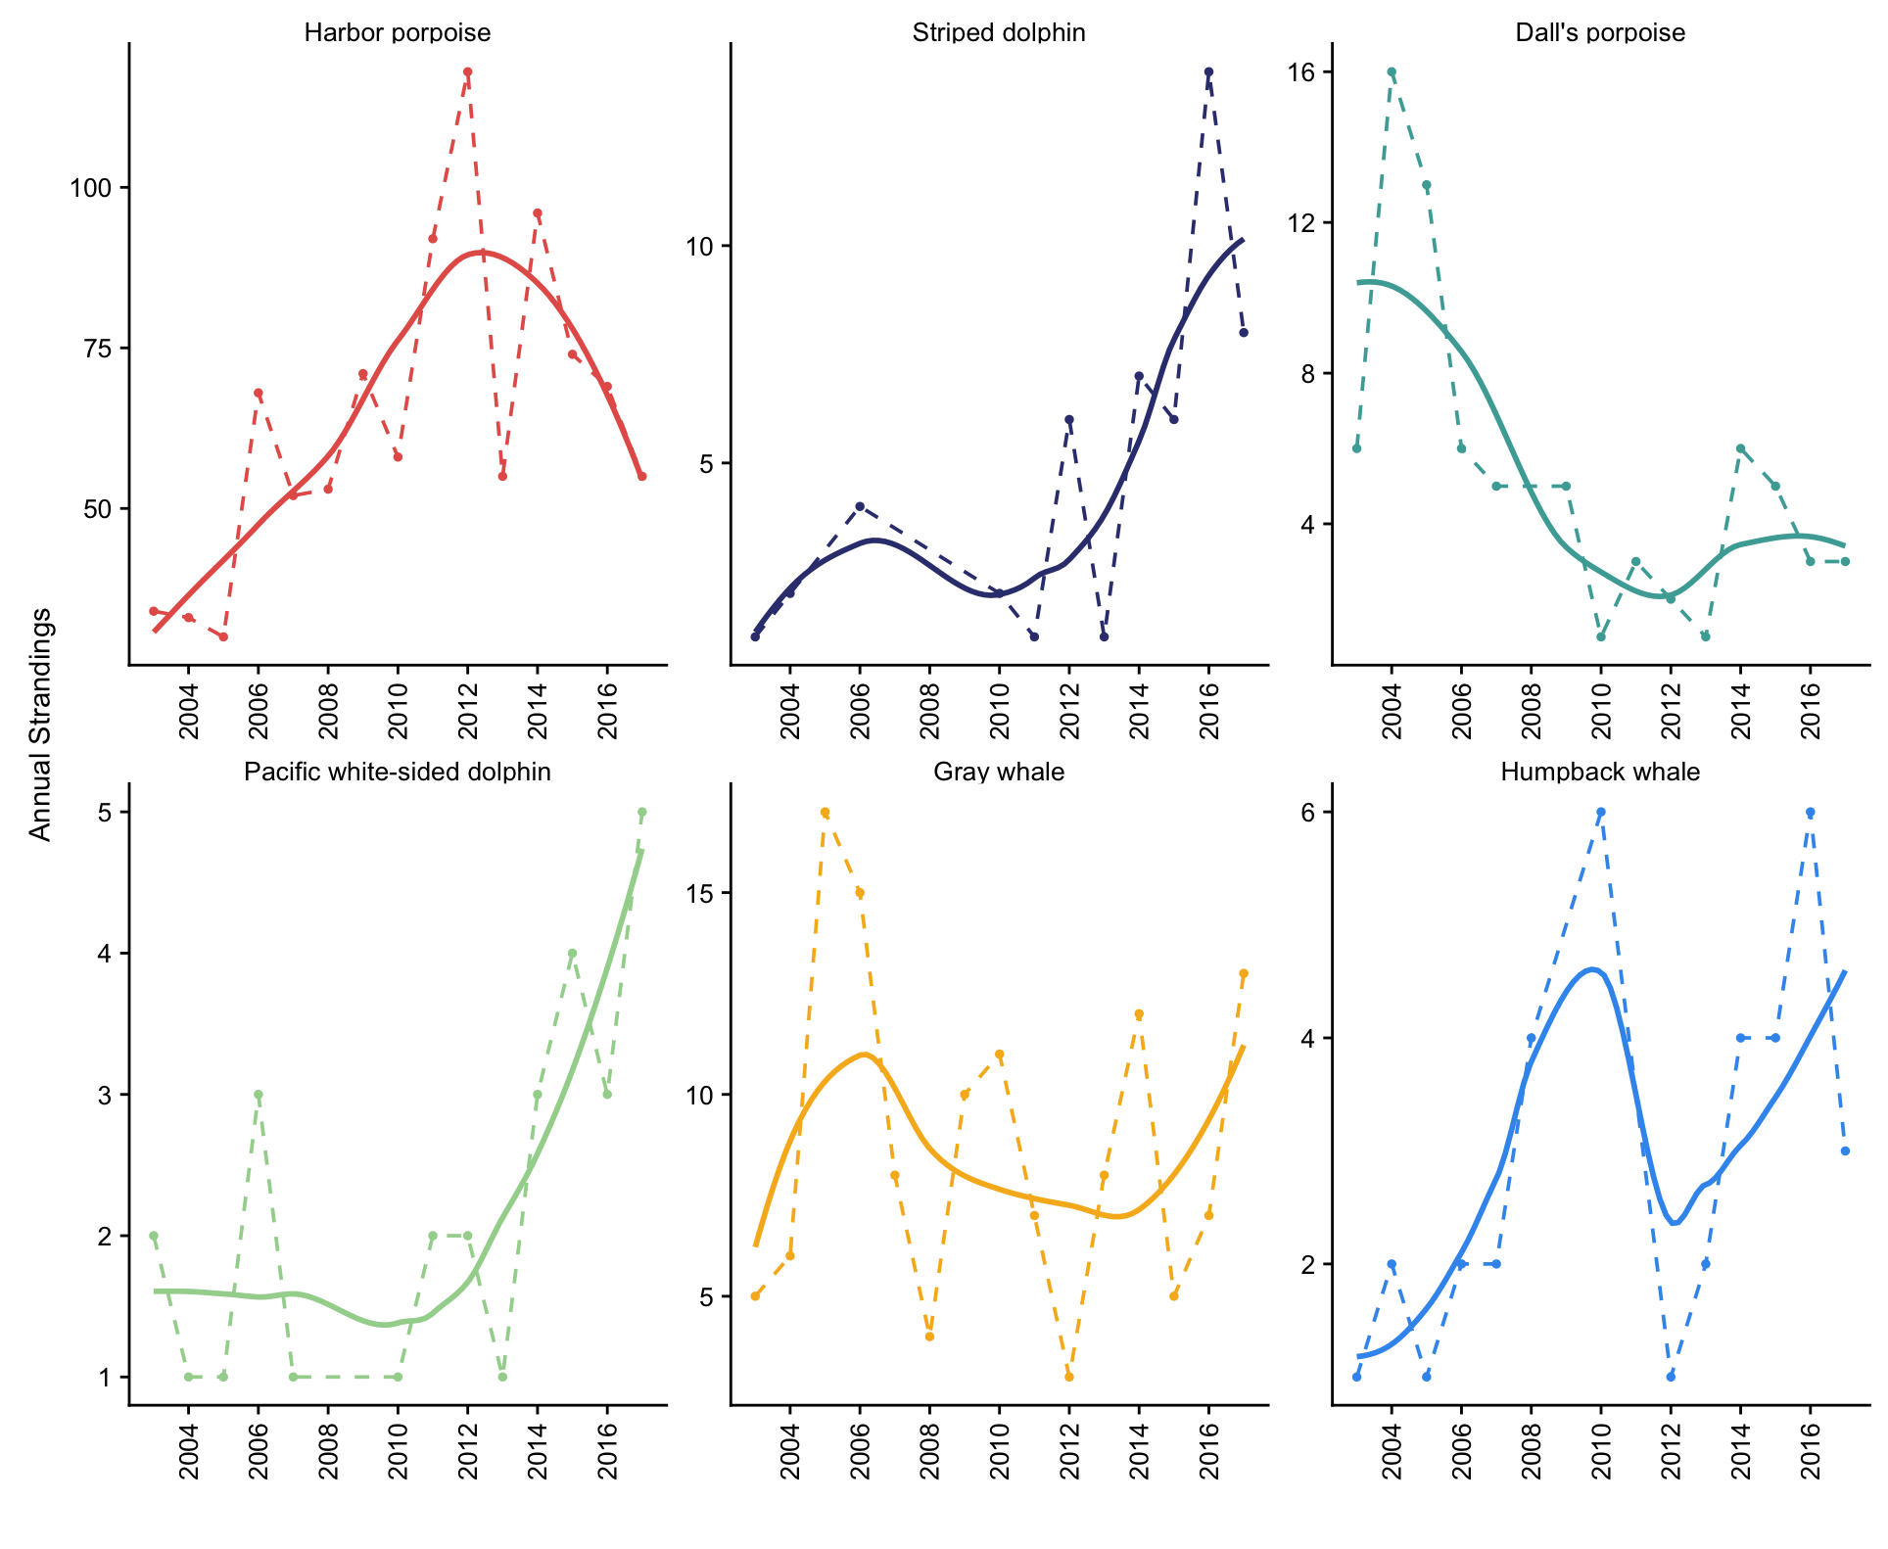

Figure 1. Annual number of cases (dotted) and loess line (solid) for the six most commonly stranding species over the study period.

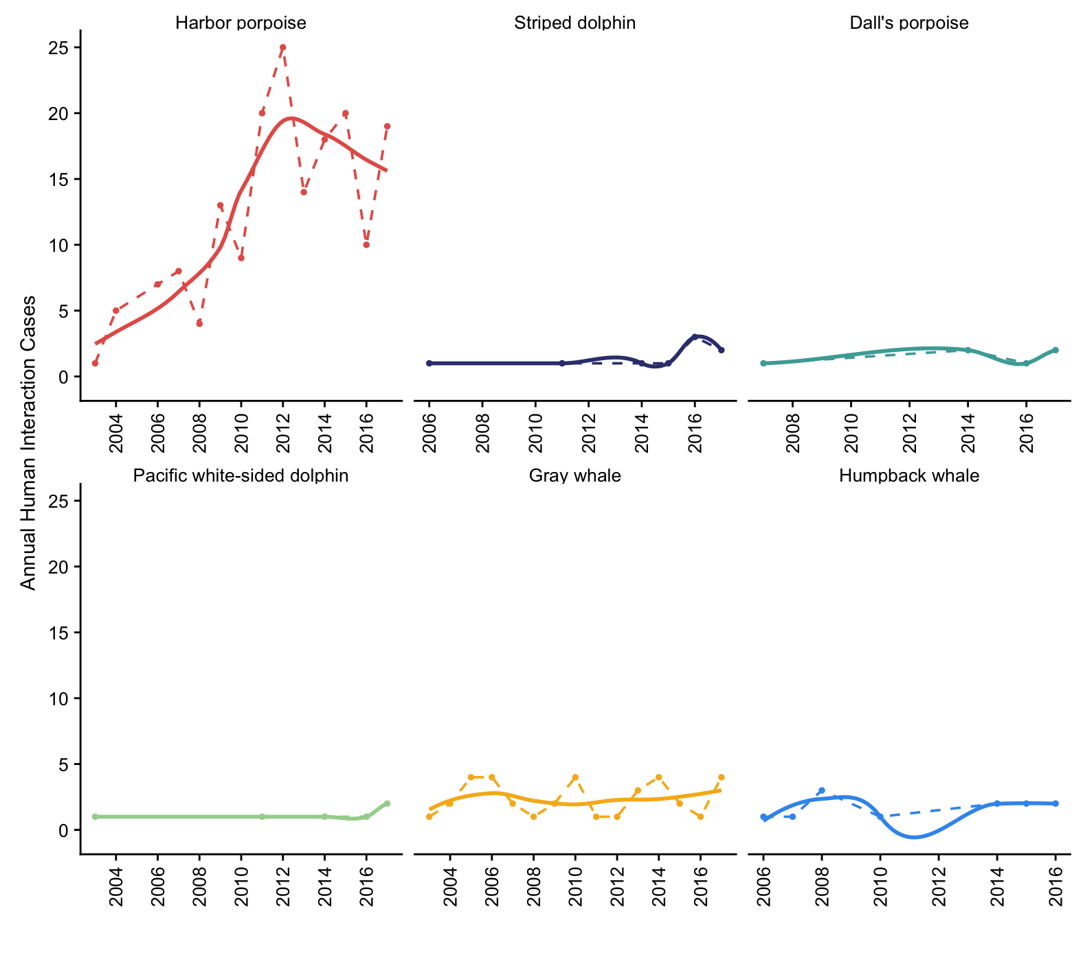

Figure 2. Annual number of human interaction cases (dotted) and loess line (solid) for the six most commonly stranding species over the study period.

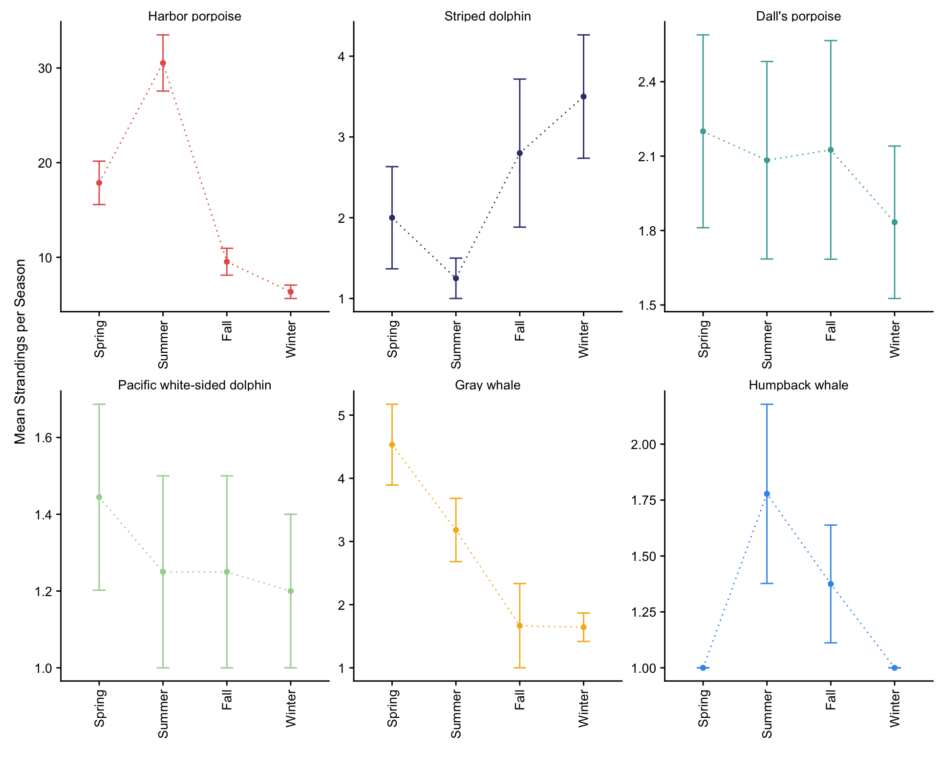

Figure X. Mean seasonal strandings for the six most commonly stranded species, with error bars representing the standard error of the mean.

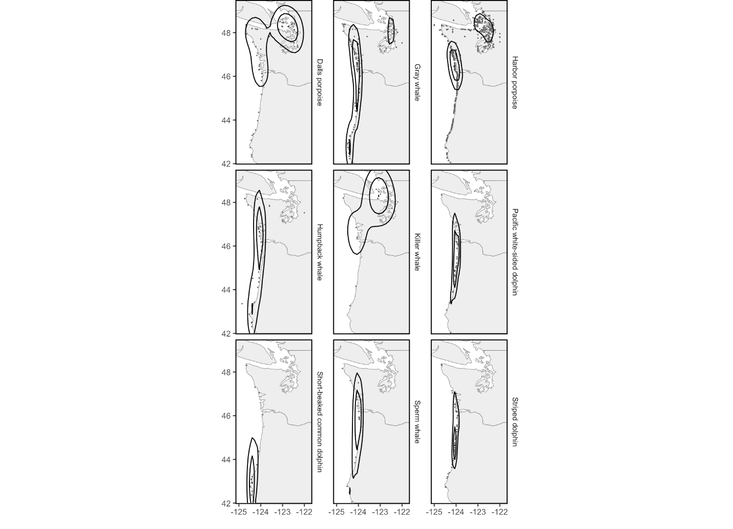

Figure 1S. This includes a few more species than the seasonal one below….. one thing we could do is make a non-seasonal figure like this for all the species that we don’t include in a seasonal one, and put it in a supplemental?

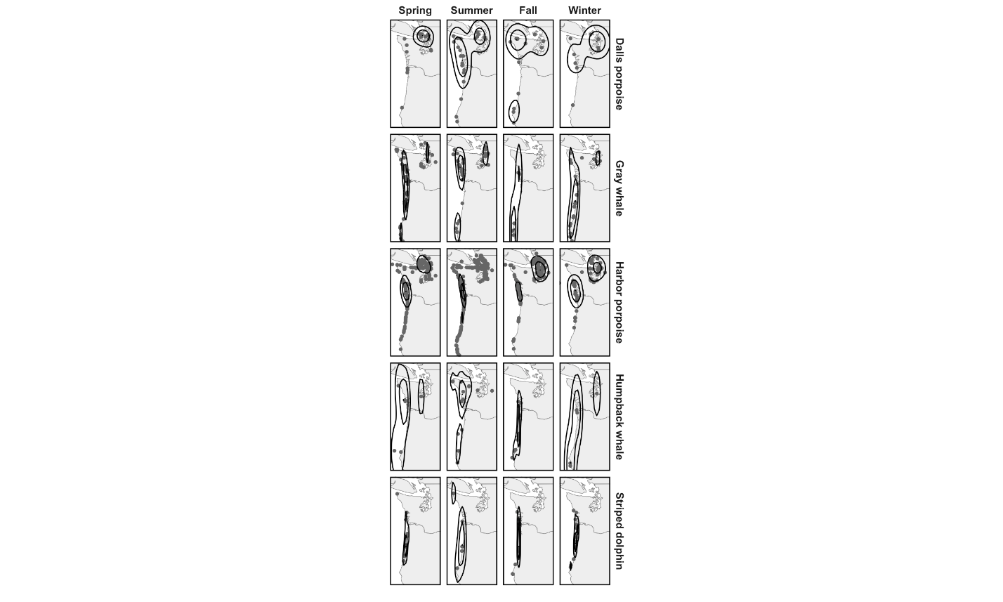

Figure 3. Seasonal distribution of stranding cases for each of the six most commonly stranding species. Kernel density estimation is calculated for each season and species separately, therefore contour lines are intended to show the spatial density of strandings in each panel relative to itself, not compared to others.

TABLE 1. Local environmental data, large-scale oceanographic indices, and prey density data used in this analysis, derived from the California Current Integrated Ecosystem Assessment project. *Prey density catch per unit effort (CPUE) are derived from surface trawls that may not accurately represent prey availability along the coast. Results including these variables should be interpreted with caution.

|  |  |
| --- | --- |
| *Variable* | *Location* |
| Sea surface temperature (°C) | 39°N/124°W, 45°N/125°W |
| Upwelling (m3/second/100m) | 39°N/125°W, 44°N/125°W |
| Wind (m/s) | 39°N/124°W, 45°N/125°W |
| MEI | Basin-wide |
| NPGO | Basin-wide |
| PDO | Basin-wide |
| Northern/Southern Copepod biomass anomaly | 44.6°N |
| Sardine, anchovy, market squid CPUE* | Summer trawls 44-48°N |

TABLE 2. Cetacean strandings and human interaction (HI) cases in Oregon (OR) and Washington (WA) from 2003-2017 by species and sex.

|  |  |  |  |  |  |  |  |  |
| --- | --- | --- | --- | --- | --- | --- | --- | --- |
| Species | Total | OR | WA |  | Male | Female | Unidentified | HI Cases |
| **Balaenopterid** |  |  |  |  |  |  |  |  |
| *Balaenoptera musculus* | 1 | 1 | 0 |  | 1 | 0 | 0 | 0 |
| *Balaenoptera physalus* | 9 | 1 | 8 |  | 6 | 0 | 3 | 6 |
| *Balaenoptera borealis* | 1 | 0 | 1 |  | 1 | 0 | 0 | 1 |
| *Balaenoptera edeni* | 2 | 0 | 2 |  | 2 | 0 | 0 | 2 |
| *Balaenoptera acutorostrata* | 6 | 3 | 3 |  | 2 | 4 | 0 | 2 |
| *Megaptera novaeangliae* | 38 | 18 | 20 |  | 17 | 10 | 11 | 12 |
| **Eschrichtiidae** |  |  |  |  |  |  |  |  |
| *Eschrichtius robustus* | 131 | 53 | 78 |  | 45 | 39 | 47 | 36 |
| **Physeteridae** |  |  |  |  |  |  |  |  |
| *Physeter macrocephalus* | 17 | 12 | 5 |  | 2 | 6 | 9 | 5 |
| *Kogia breviceps* | 5 | 3 | 2 |  | 2 | 2 | 1 | 0 |
| *Kogia* spp. | 1 | 0 | 1 |  | 0 | 0 | 1 | 0 |
| **Ziphiidae** |  |  |  |  |  |  |  |  |
| *Berardius bairdii* | 5 | 2 | 3 |  | 1 | 3 | 1 | 2 |
| *Ziphius cavirostris* | 7 | 7 | 0 |  | 6 | 0 | 1 | 0 |
| *Mesoplodon carlhubbsi* | 1 | 0 | 1 |  | 0 | 1 | 0 | 0 |
| *Mesoplodon densirostris* | 2 | 0 | 2 |  | 1 | 1 | 0 | 1 |
| *Mesoplodon stejnegeri* | 3 | 2 | 1 |  | 1 | 2 | 0 | 1 |
| **Delphinidae** |  |  |  |  |  |  |  |  |
| *Orcinus orca* | 13 | 1 | 11 |  | 4 | 5 | 4 | 2 |
| *Globicephala macrorhynchus* | 1 | 1 | 0 |  | 0 | 1 | 0 | 0 |
| *Grampus griseus* | 7 | 5 | 2 |  | 5 | 2 | 0 | 1 |
| *Lagenorhynchus obliquidens* | 29 | 22 | 7 |  | 11 | 14 | 4 | 6 |
| *Tursiops truncatus* | 5 | 1 | 4 |  | 1 | 3 | 1 | 0 |
| *Delphinus capensis* | 7 | 2 | 5 |  | 4 | 2 | 1 | 0 |
| *Delphinus delphis* | 13 | 10 | 3 |  | 6 | 6 | 1 | 1 |
| *Delphinus* spp. | 1 | 0 | 1 |  | 0 | 0 | 1 | 0 |
| *Stenella attenuate* | 1 | 1 | 0 |  | 0 | 1 | 0 | 0 |
| *Stenella coeruleoalba* | 52 | 42 | 10 |  | 29 | 17 | 6 | 9 |
| *Lissodelphis borealis* | 9 | 6 | 3 |  | 5 | 3 | 1 | 1 |
| **Phocoenidae** |  |  |  |  |  |  |  |  |
| *Phocoena phocoena* | 958 | 275 | 683 |  | 356 | 302 | 300 | 173 |
| *Phocoenoides dalli* | 75 | 16 | 59 |  | 30 | 13 | 32 | 6 |
| Phocoenidae hybrid | 2 | 0 | 2 |  | 1 | 1 | 0 | 0 |
| **Unidentified Species** |  |  |  |  |  |  |  |  |
| Unidentified delphinid | 6 | 5 | 1 |  | 1 | 0 | 5 |  |
| Unidentified phocoenid | 9 | 0 | 9 |  | 0 | 0 | 9 | 2 |
| Unidentified odontocete | 16 | 10 | 6 |  | 0 | 1 | 15 |  |
| Unidentified mysticete | 7 | 3 | 4 |  | 0 | 0 | 7 |  |
| Unidentified cetacean | 23 | 14 | 9 |  | 2 | 2 | 19 | 2 |
| **Total** | 1463 | 517 | 946 |  | 542 | 441 | 480 |  |

TABLE 3. Best models predicting monthly stranding counts for harbor porpoise, grey whale, Dall’s porpoise, and striped dolphin over the study period, including exponentiated coefficient estimates (values >1.0 indicate positive multiplicative relationship and values <1.0 indicate negative), log-scale standard error, z value, *p* value, AIC, and chi-square test statistic indicating overall model fit. Significant covariates (α < 0.1) indicated in bold. Species whose best models included indices of prey density were repeated without these variables.

|  |  |  |  |  |  |  |  |
| --- | --- | --- | --- | --- | --- | --- | --- |
| Species | Variable | Estimate | Std Error | z | P(>|z|) | AIC | χ2 |
| **Harbor porpoise** | Intercept | 179.47 | 0.42 | 12.34 | <0.001 | 660.25 | 0.498 |
| **SST 44° (2 mo lag)** | **0.73** | **0.04** | **-8.50** | **<0.001** |
| **MEI (1 mo lag)** | **0.87** | **0.08** | **-1.68** | **0.092** |
| N. CBA | 0.95 | 0.14 | -0.35 | 0.73 |
| **Market squid** | **2.58** | **0.31** | **3.03** | **0.002** |
| **Sardine** | **0.59** | **0.176** | **-3.01** | **0.003** |
| **Harbor porpoise**  *(without fish)* | Intercept | 175.91 | 0.44 | 11.63 | <0.001 | 674.56 | 0.484 |
| N. CBA | 0.91 | 0.15 | -0.66 | 0.508 |
| **SST 44° (2 mo lag)** | **0.75** | **0.04** | **-7.63** | **<0.001** |
| MEI (1 mo lag) | 0.91 | 0.09 | -1.04 | 0.29 |
| **Grey whale** | Intercept | 2.07 | 0.10 | 7.22 | <0.001 | 192.24 | 0.96 |
| **Upwelling 39°** | **0.99** | **0.001** | **-2.07** | **0.037** |
| **N. CBA** | **0.67** | **0.19** | **-2.07** | **0.038** |
| **MEI (1 mo lag)** | **0.77** | **0.12** | **-2.09** | **0.037** |
| **Dall’s porpoise** | Intercept | 1.15 | 0.17 | 0.84 | 0.40 | 124.35 | 0.99 |
| SST 39° anomaly | 0.84 | 0.164 | -1.09 | 0.273 |
| **NPGO (1 mo lag)** | **0.76** | **0.145** | **-1.92** | **0.055** |
| **Sardine** | **1.52** | **0.242** | **1.72** | **0.085** |
| **Dall’s porpoise**  *(without fish)* | Intercept | 1.28 | 0.13 | 1.89 | 0.059 | 123.77 | 0.99 |
| SST 39° anomaly | 0.86 | 0.164 | -0.85 | 0.39 |
| N. CBA | 0.73 | 0.25 | -1.22 | 0.22 |
| ***~~Dolphinidae~~*** | ~~Intercept~~ | ~~0.29~~ | ~~0.78~~ | ~~-1.57~~ | ~~0.11~~ | ~~192.56~~ | ~~0.99~~ |
| **~~SST 39° (2 mo lag)~~** | **~~1.13~~** | **~~0.06~~** | **~~1.99~~** | **~~0.046~~** |
| ~~PDO (1 mo lag)~~ | ~~0.94~~ | ~~0.09~~ | ~~-0.67~~ | ~~0.50~~ |
| **Striped dolphin** | Intercept | 1.22 | 0.28 | 0.71 | 0.48 | 62.09 | 0.98 |
| **MEI (1 mo lag)** | **2.47** | **0.46** | **1.97** | **0.049** |
| N. CBA | 2.57 | 0.46 | 1.97 | 0.13 |

1. https://www.integratedecosystemassessment.noaa.gov/regions/california-current/cc-indicator-status-trends